BACKHOE ASSEMBLY
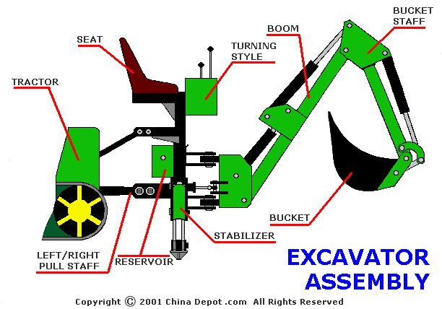
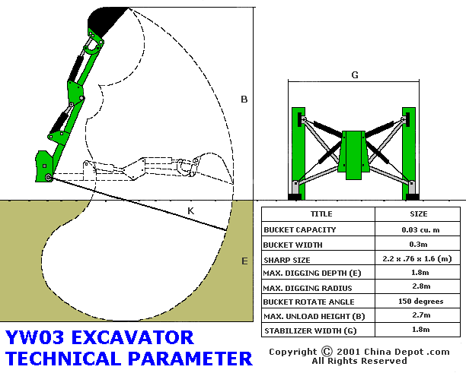
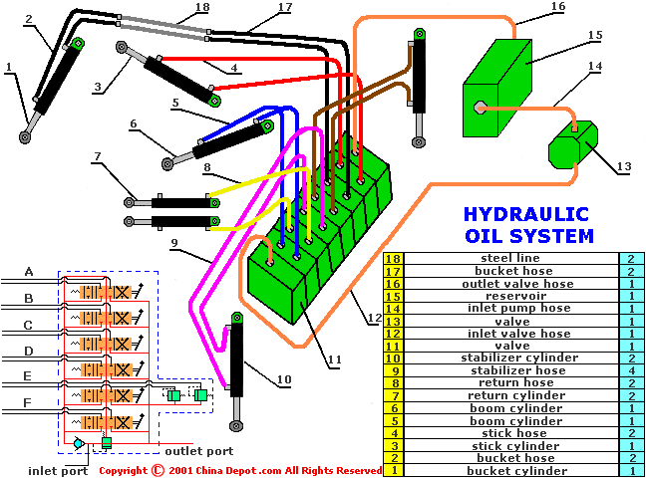
A | To Stick Cylinder
B | To Bucket Cylinder
C | To Right Stabilizer Cylinder
D | To Left Stabilizer Cylinder
E | To Return Cylinder
F | To Boom Cylinder
BRIEF INTRODUCTION
The YW03 three-points hitch hydraulic excavators have many excellent characteristics such as facility loading and unloading, operation agility, etc. Its main functions are digging ditches, eliminating dirt channels in towns or countryside.

SAFETY REGULATION AND IMPORTANT CAUTION
SAFETY REGULATION
1. Operate your excavator in accordance with the safety regulations of the tractor.
2. Only persons who have been trained on tractors and fully understand this manual should operate the excavator.
3. Regarding traveling: To avoid excavator drop-down, be sure the safety lock is in position when traveling on roads. To avoid tractor tipping or sliding, travel very carefully with your excavator and at a safe, low speed while turning. Also, when traveling down roads, be sure the stabilizers are in the fully raised position.
4. When operating the excavator, area should be free of persons and obstacles.
5. To avoid the natural drop-down of the excavator, be sure excavator boom is resting on the ground in a stabilized condition after working.
6. In order to maintain a higher stability when traveling with the excavator, add additional weight in the tractor's front-end (about 80kg).
IMPORTANT NOTICE
1. Work the excavator load-free (no digging) the first time you operate the excavator after it has been assembled to confirm unit is working correctly. Once you do this, you can start your labor.
2. Always check all nuts and bolts; immediately tighten any loose ones you may find (ESPECIALLY THE BOLTS UNDER THE CONTROL VALVE BLOCK OR YOU MAY BLOW OUT THE O-RING SEALS).
3. Add hydraulic oil and lubrication oil if necessary. Check all hoses, seals, couplers, etc. DO NOT operate your excavator if any leaking exist.
4. To avoid serious damage to excavator or tractor, do not move control levers too quickly (especially with the bucket filled). Control levers should be moved gently and steady.
5. Remove the lock pin before operating excavator. Don't start digging before the stabilizer has firm contact with ground. Make sure stabilizer is in highest position when traveling.
6. Don't adjust hydraulic valve unless qualified mechanic recommends it.
7. To prevent pressurized hydraulic oil from escaping when disconnecting any hoses, steel lines or couplers, move the control levers in all directions. The oil will return to the sump of the tractor.
8. Don't transport your excavator with the bucket fully raised.
9. When traveling with your excavator, do not make sudden starts, stops, or turns at high speeds. Do not exceed safe speed limits or sudden starts when climbing grades.
10. Watch out for low overhead or hanging wires. Don't touch wires with any part of your excavator. Keep your work area clear of obstacles at all times.
11. Before swinging your excavator from side to side, make sure you have enough space to do so and all persons & obstacles are clear of excavator.
12. Be extra careful when working on hillsides or close to ditches or any place where the danger of tipping or sliding is possible.
13. Don't attempt any repairs or maintenance of your excavator while it is in operation. Always turn off tractor before making any repairs, maintenance, and adjustments. Be sure the repair tools used are designed by the manufacturer for the specific task.
14. Keep all nuts and bolts tight (ESPECIALLY THE BOLTS UNDER THE CONTROL VALVE BLOCK OR YOU MAY BLOW OUT THE O-RING SEALS). Replace any damaged or worn parts immediately. Make sure replacement parts are of equivalent strength and quality.

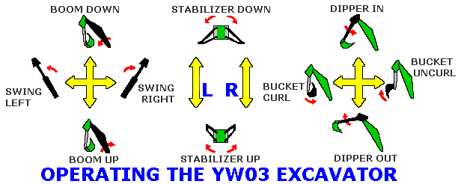

MAINTENANCE AND LUBRICATION
The warranty period is one year from original date of purchase for parts. To verify the warranty period, you should keep the sales slip for proof of purchase date. This warranty doesn't cover damages caused by accident, misuse, or tampering with the product. A charge will be made for these repairs.
Failure to perform the routine maintenance procedures outlined below may cause your excavator to operate improperly. Such operation could lead to personal injury. Your excavator requires a few minutes of maintenance before each usage. For your own safety, follow the procedures suggested below.
1. Don't service the excavator while it is operating. Remove all power from both tractor and excavator while servicing the excavator.
2. To avoid injury from escaping pressurized hydraulic oil, move the control levers in all directions before disconnecting any hoses, steel lines, and couplers.
3. Clear the suction line filter after the first 10 hours of operation.
4. Check all hardware and hoses, particularly the three-points bolts, lower links pins, locking pins, and the snap lock pins in the three-points mounting to link in order to be sure they are secure. Check all retaining bolts and pins.
5. Check the hoses for cracks, cuts, or leaks. If a hose is defective, replace it at once.
6. Check for any hose that may be rubbing against sharp objects. If any such hose is found, check it for damage and immediately move it to a safer place.
7. Lubricate all joints in need before operation and after working.
8. To avoid injury from escaping pressurized hydraulic oil while disconnecting the excavator oil line from the tractor, slow the tractor RPM down until turned off.
9. Once the excavator is removed, perform the recommended procedures below:

STORING FOR SHORT PERIODS
*Coat all exposed cylinder shafts with grease or a corrosion preventive.
*Install dirt caps on the quick couplers to prevent dirt contamination of the hydraulic oil system, or if possible, connect the quick couplers together.

STORING AT THE END OF SEASON
*Coat all exposed cylinder shafts with grease or a corrosion preventive.
*Store the excavator in a dry, protective place.
*Clear the unit of all mud and dirt, touch up the paint to prevent rust.
*Install dust caps on the quick couplers to prevent dirt contamination of the hydraulic system or connect them together.

AT THE START OF A SEASON
*Clean all dirt and debris from all quick couplers.
*Check all hydraulic hoses and replace if necessary.
*Tighten loose nuts and bolts.
*Lubricate all moving parts.
*Check the bucket teeth. Sharpen or replace if necessary.
*Run the unit slowly and check the operation control system. Make sure its in good condition before you start to dig.

TECHNICAL PARAMETERS
TITLE | SIZE
Bucket Capacity (m³) | 0.03
Bucket Width (m) | 0.3
Sharp Size (m) | 2.2 x 0.76 x 1.6
Maximum Digging Depth (m) | 1.8
Maximum Digging Radius (m) | 2.8
Bucket Rotation Angle | 150º
Maximum Unload Height (m) | 2.7
Stabilizer Width (m) | 1.8
You can reference the technical parameter figures.

ASSEMBLY
REFERENCE THE ASSEMBLY FIGURE AND HYDRAULIC OIL LINE SYSTEM OF THE YW03 HYDRAULIC EXCAVATOR.
1. Be sure your tractor's left/right low pull lever is pull and lock equipped. Otherwise, the excavator won't line-up with the tractor causing injury or machine failure.
2. Put the tractor's raise lever to the lowest position when connecting the excavator, then adjust the raise lever so the locking nut locks. Make sure the excavator center lines up and connects with the tractor.
3. Don't raise the excavator until the tractor and excavator are connected with 3 connecting pins.
4. Replace the parts connecting both tractor and excavator if necessary, making sure the replacements have a strength equivalent to or greater than the original parts.
5. The excavator valve must be compatible with the hydraulic system that will be powering it.
6. The excavator has been filled with oil at the factory. The oil in the unit is compatible with most tractor manufacture's oil. Do not move control levers on unit until after excavator is connected to the tractor or the independent hydraulic oil system has been finished.
7. Many tractor systems exceed the flow rate specified for your excavator. The flow may be adjusted by throttling the engine RPM down to obtain an acceptable flow rate. Adjusting the flow rate correctly could prevent sudden shock loads on the cylinders, hoses, etc. This will result in a smoother operation and reduced maintenance costs & down time.

STANDARD PIECES
code | specification
GB1235-76 | o-ring seal on 12 x 1.9
GB301-64 | Bear 8206

GENERAL TROUBLESHOOTING
PROBLEM | POSSIBLE CAUSE | POSSIBLE REMEDY
Excavator Can't Operate | 1. low oil supply  2. master valve sticks | 1. add oil to proper level  2. clean valve or repair master valve
Sticking Plungers | 1. excessively high oil temperature  2. dirt in oil  3. pipe fitting too tight  4. valve warped  5. high pressure in valve  6. plunger bent  7. spring damaged  8. valve not at thermal equilibrium  9. spring and cap in bad position | 1. eliminate restrict and filtering system  2. change oil or clean system  3. check torque  4. replace valve  5. check with gauge on inlet and cylinder lines  6. loose valve and check  7. replace faulty parts  8. warm up system  9. loosen the cap and retighten
Leaking Seals | 1. paint on or under seal  2. excessive back pressure  3. dirt under seal  4. scored plunger  5. loose seal plates  6. cut or scored seal | 1. clean and retighten seal  2. open and enlarge oil to reservoir  3. clean and retighten  4. replace valve or section  5. clean and retighten  6. replace faulty parts
Unable to Move Plunger | 1. dirt in valve  2. plunger cap full of oil  3. connection is bad | 1. clean and flush out  2. replace seals  3. clean connecting lines

