Part II: A Crated Tractor Adventure – Crawler Assembly

The CTOA message board has a variety of opinions regarding the purchase and use of China Tractors. But one of the most controversial topics is that of buying and assembling a crated tractor without benefit of dealer support, so it may help, as you read this “adventure,” to know three things about me: first, my motivation was not necessarily to save money; second, I came into this knowing nothing about tractors; and third, I’m not mechanic by trade.

In my opinion, a can-do attitude with a systematic approach will get you through just about anything. The key is to develop the ability for making mistakes that are easy to correct and are never catastrophic. Occasionally I violate this principle by succumbing to “wishful thinking” and so occasionally pay the price. I rationalize that my shortcuts win more often than not, but as I get older, I’m not so sure. People that are patient seem to be the more consistent winners. In any case, it’s necessary to find an appropriate starting place. Traditionally, that’s been the Assembly Manual.

I like assembly manuals. The computer industry has a saying for people new to the use of computers: “Read The Frigging Manual” (RTFM for short). Having been involved with computers for over 45 years, and having written a few manuals myself, I’m quite sensitive to this admonition. Indeed, our society has been conditioned over the years to expect assembly manuals for almost everything. Unfortunately, most of today’s assembly manuals are filled with warnings and legal disclaimers, in three or more languages, to the point where there is little room for anything useful. Not a problem with my Chinese crawler, however. While there wasn’t a specific assembly manual, the parts manual, with lots of useful diagrams, is a good substitute.

Lesson 1: Pictures and diagrams are the international language for most of the world!

Note: For those interested, the appendix contains a list of my crawler documentation, along with some appropriate comments.

Where to start

In my experience, selecting the right place to start a new project often determines how quickly you’ll finish. Generally I like to start with the stuff I feel the most comfortable with. Something small enough that it won’t be too much of a setback if it goes badly. In this case that involved installing the backhoe stabilizers. No problem with the mechanical assembly, but the hydraulics was all brand new to me. If you’ve never worked with high pressure (> 2000 psi) hydraulics it can be a bit confusing. So I did what I usually do when I want information. I searched the web and found the desired information on John Serbaniewicz’s website (JohnS of CTOA). John had a link to the US Army’s Hydraulics Field Manual, FM-5-499, which is a downloadable 1.42 Mbyte pdf file. Great manual. It provided just about everything I needed to know for installation. For reference, the link to the Army’s Library of good stuff is: http://www.adtdl.army.mil/atdls.htm.

Lesson 2: Most of the time, the web will have enough information about the thing in question to figure out the necessary details.

First Problem/Mistake

In the beginning, I didn’t understand the purpose of the supplied hose adapters, but I assumed they were necessary in the assembly. Wrong! They wouldn’t connect to the hoses. OF COURSE, they wouldn’t connect to the hoses as the male cylinder connector used a face-centered “o” ring for the seal, while the adapters depended on a female flare fitting for the seal. I must have been daydreaming because I cross threaded a hose connector before realizing my mistake.

Lesson 3: Don’t force it! If it doesn’t screw easily, and the threads don’t seem damaged, it HAS to be the wrong thread pitch!

Such mistakes have a way of increasing a guy’s frustration factor. So what to do next?

Lesson 4: When you encounter a frustrating problem, don’t panic. Go onto something else. The answers always come in the middle of the night. You’ll know how to fix it tomorrow.

As it turns out, there are several metric thread standards and several hydraulic port sealing styles. Many manufacturers are still in the process of converting to the newer ISO standards, but the majority of metric fasteners are still being manufactured to the DIN (a German standard that has existed for a long time). In addition, there is the ANSI (American) standard which is essentially in agreement with the ISO standard, and then there is the JIS (Japanese standard) based on the DIN standard with modifications for the specific needs of the Japanese market (mostly the electronic sector).

The big manufacturers, who want a “differential advantage” over their competition, like to use the latest and greatest stuff (e.g., the ISO standard). But that’s not the Chinese. They use what’s most prevalent in the world (DIN) to make their tractors easier to fix. Fortunately, I found a DIN tap with the right thread pitch to re-tap the connector’s first couple of threads to fix it. Fortunately, the seal doesn’t depend on the threads.

Removing the Backhoe

As it turns out, I won’t be able to use the backhoe until I can buy a diverter valve and some quick-disconnect hose connectors so I set about removing the hoe in preparation for installing the 3-point hitch.

Since I was now familiar with how the hoe connects to the tractor, removing it wasn’t quite as difficult as installation, but still, it took almost three hours. If hydraulics are available it’s easier because then you can use the stabilizers to lift and support the hoe. But since I didn’t have hydraulics, once again I used jacks and blocks to support the hoe to where I could remove the bolts from the bracket.

I also removed the hoe installation brackets so that I could install the hitch’s lift arms. Here’s a photo showing the right bracket still in place with the left bracket removed. The splines for the left lift arm is the rusty redish thing on the left of the housing.

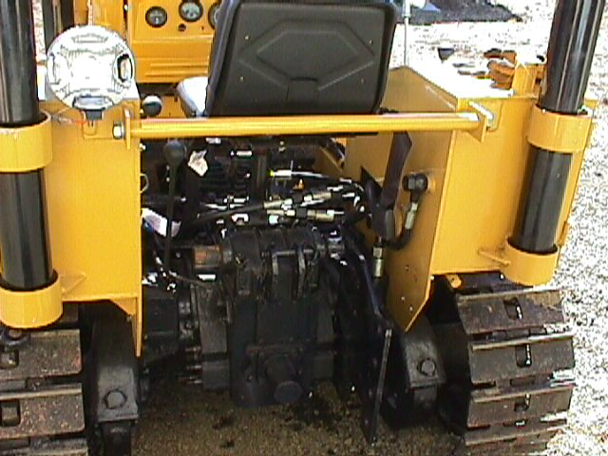

As previously mentioned, before I reinstall the hoe, I’ll mount a diverter valve with quick disconnects at the rear of the tractor. Here’s the Dozer’s hydraulic diagram (inspired by Mike Stuart) that shows the location of the planned diverter valve. As you can see, the diverter valve splits the high pressure flow from the hydraulic pump between the backhoe and the dozer’s multi-spool, control valve.

It’s not possible to use a “T” in a high-pressure line for this purpose because, as Mike explained, any load on either the backhoe or the blade would cause the oil to bypass the load to return to the reservoir through the opposite valve. Diverter valves are spring actuated by the load to prevent that from happening. On the other hand, it is possible to install a “T” in the low-pressure suction line using ordinary hose clamps since there’s no significant pressure.

Dozer Hydraulic Plumbing Diagram

6-Way Blade Cylinders

Tilt
3-pt Lift Cylinder

Lift

Angle
4-Spool, 3-Position
4-Way Directional Valve

Tank

Pump

Diverter

Backhoe

Installing the Blade Carriage (Frame)

If it’s not obvious by now, I’m pretty much by myself in these efforts. The OSHA lifting regulations of 50 lbs (100 lbs for heavy equipment operators) don’t apply to me but that doesn’t mean I use a lot of brute force. Not anymore. Many years ago I bought a book titled Moving Heavy Things. Essentially it was a collection of techniques for moving heavy structures that were used by the pioneers who built this country. It’s really quite amazing what one or two people can do with levers, jacks and rollers. Here’s a photo of the blade carriage after installation. Our chocolate lab, Cheyenne, is there in the left bottom corner.

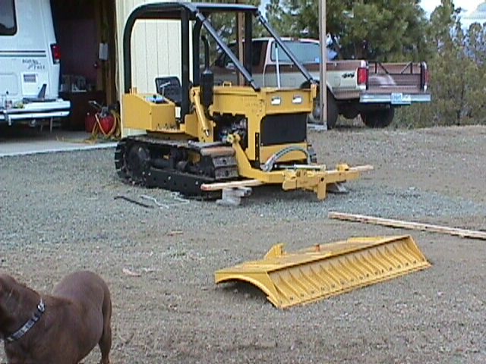

I was too busy to take a photo during installation, but you’ll notice that the front of the frame is supported by a 2x4 on top of wooden blocks. That allowed me to get the frame over the front axel. Then I tied a rope to end of the frame arms and looped it across the hood of the tractor so that I could gently move the frame to the rear for attaching to the tractor’s swing shaft, which is located just forward of the big drive sprockets. That worked until I ran out of hood, so then I used the rope to pull the frame the rest of the way. It was easier than it sounds. You can see the rope lying on the ground by the right side of the tractor.
Installing the Blade

The first step to installing the blade is getting it into position. The blade carriage was probably around a hundred pounds, but the blade is twice that, so I had to skid it on 2x4s as shown in the photo below. Notice the pin projecting out from the center of the blade. There’s a matching hole in the blade carriage. So the trick is to position the blade carriage at just the right height for that pin. Once positioned, I used one of the 2x4s as a lever to lift the blade upright. Once the hole matched, I started the tractor and drove it forward a couple of inches to seat the pin. Again, it’s easier than it sounds.

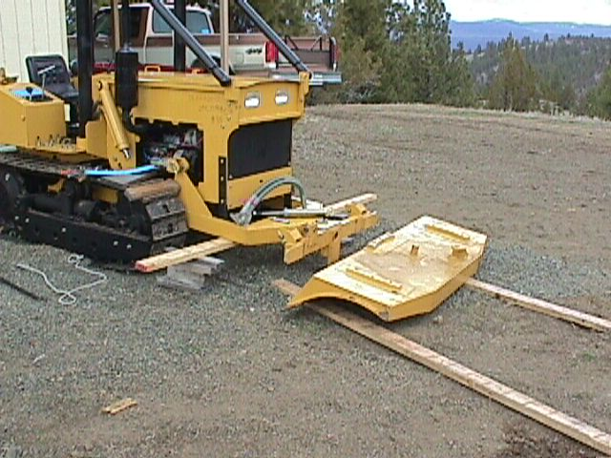

Note the hydraulic hoses coming through the frame. A plastic sack covers the connectors. Those hoses are for the “angle” cylinder (attaches to the blade) that causes the right or left corners of the blade to move down or up. The hoses connect to steel pipes that run through the left side of the enclosed frame. At the rear of the box frame, they project through a hole for connection to flexible hoses under the tractor. They were hard to connect.

Connecting the hydraulic hoses

Under the center of the tractor are four hoses on the left side, and two on the right that come from the blade control valve. Four of the hoses (two for each side) connect to steel pipes running along the top of the blade carriage for connection to the “tilt” cylinders, which cause the ends of the blade to move forward and backward.

As mentioned above, the other two hoses on the left connect to steel pipe running through the box frame for the angle cylinder.

The tractor already had the “lift” cylinders installed. That is the hydraulic hoses for the lift cylinders were installed, and the head of the cylinder was anchored to the top of tractor frame (near the instrument panel). Installation of the lift cylinders only required connecting the cylinder rod to the blade carriage. The rods were fully retracted so I started the tractor so that I could use the hydraulics to extend the rods to connect to the blade carriage.

Connecting the hoses under the tractor was a problem. Because of the track it’s not possible to see the hose ends while using two hands for the connection. So I pretty much had to blindly feel for a square connector fit while attempting to engage the threads. In retrospect, I think I would remove the operator flooring to get access. I’m not sure, but I think it would work better.

The trick in all this is to ensure that the right hose goes to the right cylinder and also to the right end of the cylinder. I tried to do a little hose tracing coming out of the spool control valve, but it’s not easy for one person. So I wound up connecting the hoses pretty much the most convenient way hoping such logic was built into the hose routing. I was half right. I got half the connections right and half wrong. I had one of the tilt cylinder hoses going to the angle cylinder, and I had two cylinder cross connections as shown in the following photo.

Actually, what you see in the photo is the “correction” that made the cylinders work properly. It’s more convenient to make a compensating cross connection on top than underneath the tractor. The principle here is to “first make it work, then make it pretty.” Later I reversed the connections, but it’s really about more than just looking pretty. When the hoses are under pressure, they tend to swell and become shorter. Cross-connected hoses are a source of mischief that could lead to early failure. And of course, I reconnected the hoses for angle and tilt cylinders (under the tractor) to allow them to work properly.

Two things: First, in one sense, this shotgun approach wasn’t all that bad. The blade operation problems were all pretty obvious to indicate the proper hose connections. But, second, every time you break and make a connection you lose about a pint of hydraulic fluid. You can’t very well catch it in a jar (I tried) as it just runs down the cylinder to puddle in numerous places. So it’s a messy business. If you can get someone to help trace out the hoses before hand, it will be quicker and certainly less messy.
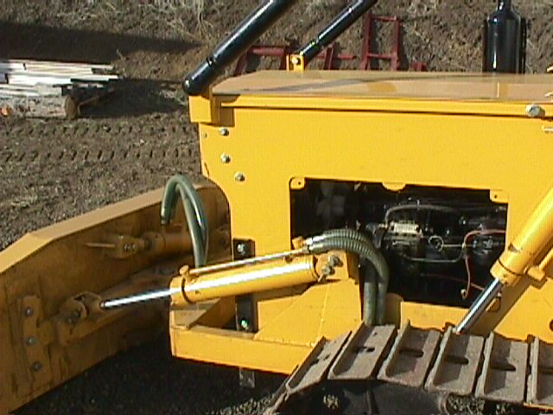

An assembly problem

In normal operation, the grease fitting on the left tilt cylinder was destroyed by the tractor’s head mounting bracket (bottom center of above photo). It was necessary to use an angle grinder to provide the necessary relief. See next photo.

In the photo notice the bright metal from the grinding operation. And that’s a new 6mm Zerk fitting to replace the China one that was destroyed.

The two yellow caps prevent the oil from leaking out of the cylinder.

However, this was the only thing I actually had to modify on the tractor to make things fit. In general, I thought the Chinese did a pretty job laying things out to make assembly fairly easy. Better than some Detroit cars that come directly from the factory. Of course, our dealer network is set up to take care of such problems, including various missing parts and bolts. I don’t know if my crawler is typical, but I was impressed with the quality of this “China crate tractor.”
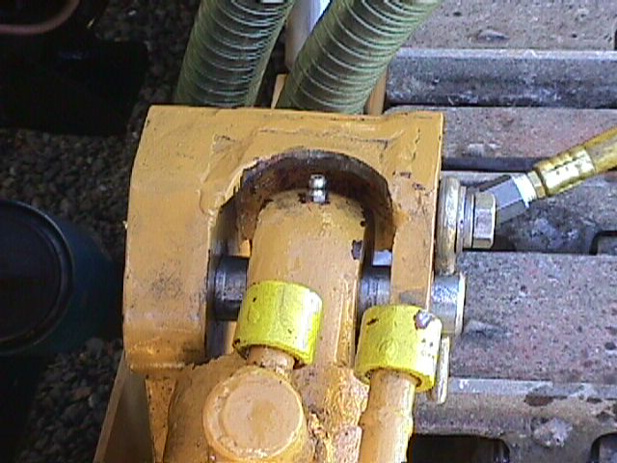

Starting the tractor

A new 12V, 90 AH, 850 CCA, battery came with the tractor. No battery acid. I was able to get Les Schwab (a tire dealer) to fill it for $10.

I had previously bought 5-gallon cans of hydraulic fluid and gear oil. I had a 5-gallon can of grease for the grease gun. I also had a half full 55-gal drum of diesel left over from my China diesel generator that I used when building my house. When I added lubricating fluids fuel to the crawler, the hour meter registered 12.4 hours.

The tractor started on the first try. Obviously the injectors still had fuel from testing in China. I checked the oil pressure and let it run for awhile. The temperature came up a little but not much. Gage operating temperature under load seems to be 40°C (104°F). My China diesel generator always ran cool but not that cool. I’ll have to see if the gage can be adjusted. All the other readings seemed reasonable, if not necessarily accurate.

First Use

My first task was to grade my entrance road after the winter’s wear and tear. That’s an easy task as shown in the following photo. The road is 1500’ long. I’m halfway back on my third pass.

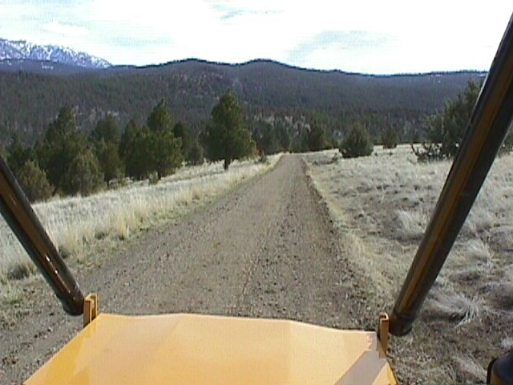

Tractor Operation

The tractor has a 6-way blade controlled by a “T-bar” lever on the operator’s right side (see photo). The lever can be moved forward and backward, left and right, and twisted clockwise and counterclockwise to control the blade's six motions.

The smaller control level to the outside of the T-bar lever controls the 3-point lift. At the far back of the console is the hydraulic reservoir dip stick and filling port. Note the air hole in the cap.

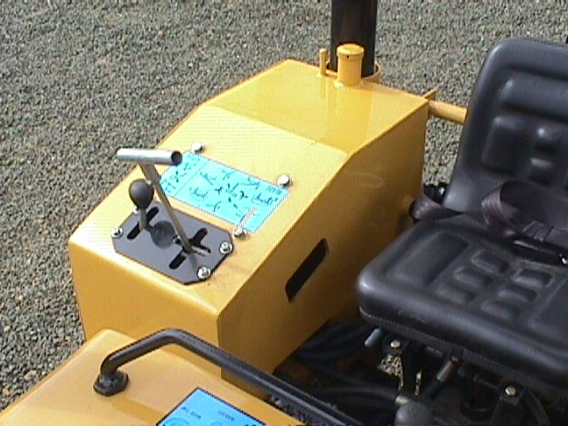

The controls on the floor include the transmission shift levers, one for H-L, and one for 4F and 1R gear. The pedal on the left is the clutch, while the two pedals on the right are for steering. Push the right pedal to go right and the left pedal to go left. Push both to execute a hard stop. See the following photo.

The throttle control lever is shown on the far left. For me, the throttle control is backward to what this old aircraft pilot is used to. With airplanes, GO means pushing the throttle(s) forward. You STOP by pulling the throttle back. The tractor is the opposite. I find myself increasing engine rpms when I want less which is not a good thing. But I can get used to it … if I have to … I first need to find out if all tractors are that way.
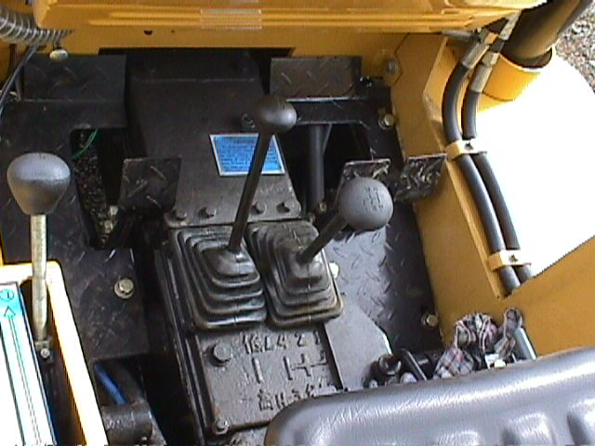

Road Grading – Dozer Blade vs. Box Blade

I initially thought that a 6-way blade would be the answer to doing a superior road grading job where so many other dozer operations fail, but I’ve learned that it’s more complicated than that.

It turns out that the cut taken by the dozer blade is as much dependent on the position of the tracks as the position of the blade. To get a level cut it’s necessary to first cut a bench with the desired slope for the tracks to begin the cut. The bottom and tops of hills also present special problems as the blade wants to continue doing whatever it was previously doing. At the bottom of a grade, it can dig a big hole fairly quickly. I now have a much better appreciation for road graders that have the blade under the center of the tractor.

The solution to many of these problems is a box blade. A box blade behind the tractor can be set to automatically cut the high spots while filling the low spots. So now I build a road by making a rough cut with the dozer blade, and finishing up with the box blade. Here’s a photo of my box blade installed on the 3-point hitch:

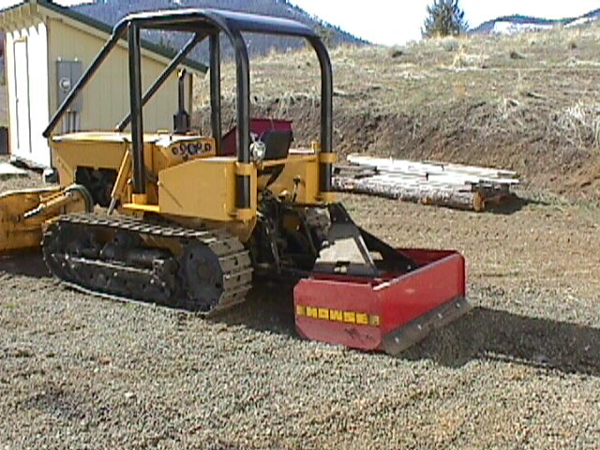

This is a 4’ box blade. However, for this tractor it should be a minimum 5’ blade and for road building a 6’ blade would be even better … but (sigh) “I got a good deal.”

Preventative Maintenance Schedule

I rewrote the PM schedule and Tractor Adjustment Instructions. Preliminary Chinese manuals seem to lose something in the translation to English. Maybe later, if volume picks up, the China tractors will come with slick manuals with better translations. Regardless, there’s enough in the preliminary manuals to get started, especially when accompanied by diagrams. But the translation errors bother me, so I often rewrite the parts I use most. The following are two examples:
Crawler Tractor Preventative Maintenance – Before Each Shift
Revised April 3, 2002

- Clean away as much dust and mud as possible
- Inspect for oil leaks around Engine, the Hydraulic Reservoir, and the Gear Cases
- Check Fluid Levels – Engine and Hydraulic Oil; Radiator & visual inspection of Gear Cases
- Fill with Diesel Fuel
- Inspect all nuts and bolts, especially the Drive Sprocket and the Cross Bar
- Check the Track Tension. If the sag exceeds 2/3”, the track must be adjusted (over)
- Inspect for cracks in all structural components
- Grease the Track Rollers (5 bottom, 1 top), the Idler (1), and the center blade pin (1) each side

Every 50 Hours (in Addition to Shift Checks)
- Check and Clean the Engine Air Filter
- Check the Water Trap filter underneath the Fuel Tank
- Grease all Cylinder Pins (10), the Swing Shaft (2), the Water Pump, and the Clutch Release Bearing

Every 250 Hours (in Addition to the 50 Hour Check)
- Check and Adjust the Brake and Steering Pedals
- Check and Adjust the tension of the Engine Belt to 15 mm (5/8”)

Every 1000 Hours (in addition to the 250 Hour Check)
- Check and Adjust the Engine Fuel Injectors.
- Check and Adjust the Inlet and Exhaust Valves (Inlet = 0.35mm, Exhaust = 0.40mm)
- Check and Torque Cylinder Head Bolts
- Check and Clean all Electrical Wire Connections
- Change all Filters and fluids, the Radiator, Engine Oil, Hydraulic Oil, and Gear Case Oil
- Clean the carbon out of the muffler
Preventative Maintenance Adjustments

Track Tension Adjustment

1. Measure the floor-to-track distance at a point half way between the carrier roller and the drive sprocket and compare it to the readings at the drive sprocket and the top carrier roller. The sag should be in the range from 1.5 – 2.5cm (2/3” to 1”) max. All measurements should be taken on hard level ground.
2. Loosen the locking bolt of the adjusting screw.
3. Turn the adjusting screw until the upper track has the proper tension. If the spring cap turns together with the adjusting screw, stop the spring cap from turning by screwing the arresting bolt into the spring cap. After adjusting, back the arresting bolt out to its original position.
4. Retighten the locking bolt of the adjusting screw.
5. Steel tracks will eventually run out of adjustment, at which point it will be necessary to remove one of the track shoes to permit further adjustment.

Clutch Adjustment
1. Measure the clearance between the clutch release fingers and the release bearing. It should be 2 – 3mm. The free play of the clutch should be 20 – 30mm. The working play should be 100 – 150mm.
2. Loosen the nuts on the push rod to enable free play adjustment. Turn the adjusting fork to obtain 20 –30mm.
3. To adjust the working play, loosen the lock nut on the stopper bolt and adjust to obtain 100 – 150mm.
4. These two adjustments should result in the proper clearance between the clutch release fingers and the release bearing. Recheck that the clearance is 2 –3mm.

Brakes and Steering Clutch Adjustment
Note: The steering pedals are integrated with the brake pedals.
1. Unlock the two adjusting bolts. Screw the bolts to their extreme end and then back off 4/5 to one turn. The clearance between the brake band and the hub should be within 1.2 – 1.5mm. Lock the two bolts.

2. Use the sequent fork to extend the brake pull rod. First, move the pin at the end of the brake rod toward the front of the groove. Then adjust the sequent fork to get a free play just greater than 30mm when pressing the brake pedal.

3. When the pedal is fully down, check that the steering clutch is completely separated to fully engage the brake (both right and left side).

The Spare Parts Issue

When I rented flat bed trailer to haul the tractor from the Port of Portland, the proprietor asked if I had to go to China for parts. He was only half joking. The spare parts issue is the most frequent question I’m asked. Again, there are no China Tractor dealers around here. People around here generally buy Fords because that’s the only dealer with full-service in the whole county. So spare parts is an obvious concern. A concern, perhaps, but not necessarily that big a problem.

Mike Stuart has generated and published, on his web site, a cross-reference list for much of the common China tractor parts such as hoses, filters, belts and more. Much of it is applicable to my tractor, but not all. For the stuff not listed, however, I do what Mike does. I measure the thing, check the specs, and then select the closest match from American catalogs. It drives my NAPA parts guy nuts. If they did that, of course, they’d be susceptible to a lawsuit should the part fail. Deep down, they know such lawsuits are frivolous but nevertheless, the mind-set is pervasive. I regret we’ve legislated so much common sense out of our day-to-day lives, but I don’t let it bother me. Apparently, it doesn’t bother Mike either.

However, for parts unique to the Guilin Crawler tractor, I have to deal directly with China. I can do this using a form that gets faxed directly to the Guilin factory in China. The form has provisions for supplying the necessary contact information for the payment of customs duties. It’s not necessarily simple, but it is straightforward and I know that people do it all the time.

The Warranty Issue

So far as I know there are no warranties from any of the China factories. To what court would you appeal to enforce such a warranty? The fact is that much International trade is based on the reputation and good will of the supplier. No frivolous lawsuits allowed.

The simple truth is that suppliers who sell Internationally utilize manufacturing processes that are very good at preventing defective equipment from crossing a nation’s boarders. That’s not to say there won’t be problems. Far from it. But most problems are caused either by unrealistic expectations, operator error, or gross misunderstandings. Some can be serious, but without a warranty, the burden is on the buyer to find a way to make the best of situation. In my opinion this is not necessarily bad and was certainly the basis for business for centuries. It’s only comparatively recently that the suing disease has become so pervasive … and I regret it.

Local dealers, however, are free to generate their own warranties, and often do. If you need a warranty, it’s best to buy from a local dealer.

The Answer: Why I Bought a Crated Tractor

In the first paragraph, I said that my motivation for buying a crated tractor was not necessarily to save money. Saving money is a by-product of the experience but was not the motivation. For me, the assembly process provided a good way to learn the machine. I intend to keep this tractor forever and to do that I need to know how it’s made. I need to know its strongest and weakest aspects as well as the operational sweet spot. The assembly process tends to force the acquisition of that kind of knowledge.

Acknowledgments

Even so, I had lots of help. Three people, who were under no particular obligation, were key to this whole operation. Roger Powell, my importer, did the most to help me acquire the tractor with the least amount of hassle. The CTOA contributions of Mike Stuart, of Maverick Tractors probably provided the most direct configuration and assembly help. In private communications, both Roger and Mike would occasionally offer some invaluable insights to the wonderful world of China tractors. These are two very knowledgable men. I hope they both get very rich in this business. And then there’s John Serbaniewicz (JohnS on CTOA), a guy much like me, who also assembled a crated wheel tractor and was kind enough to share his experiences. Finally, there is the World Wide Web and Hal Mandleman’s CTOA site, where I was able to quickly find the answers to all my most pressing questions. The web sites of Mike and JohnS were especially useful. CTOA has links to both sites and much more.

Appendix

Crawler Documentation

Crawler QA Certificate – lists the model, S/N, Build Date, Engine S/N and a list of tests performed. This is the only place I have seen ID info, although there may be a plate on the tractor that provides such information. Such ID info will be useful when ordering parts. The hour meter showed 12.4 hours which seems to be a reasonable amount of time for performing the tests indicated.

Crawler Packing List – lists the item and quantity of tools and spare parts included.

Diesel Engine Operation, Instruction and Parts List – This manual was mostly in English with some Chinese references on the Parts List. One interesting item is that the 3-cylinder TY395 engine from the Jiangsu Jianghuai Engine Works can be configured for several different horsepower ratings depending on the governor rpm setting. My model is the TY395T which is rated at 30 HP at 2000 rpm. The TY395Q is rated at 38 HP at 2400 rpm. They also have 35 HP (2400 rpm), 40 HP (2600 rpm), and 46 HP (2800 rpm) models. That pretty much defines the HP curve. Just as interesting would be the torque curve (which I don’t have – yet). Three comments:

1. Mechanical engineers tell me that the ability of an engine to do work is more closely related to torque than HP. Torque generally peaks early and can be relatively flat compared to HP. To get max HP you need higher RPMs than for max torque.

2. Engine RPM is a key design factor in the gearing of a vehicle. If you want speed, you need light weight and lots of RPM. But if you want power to move things, you need lots of weight and only as much RPM as necessary to develop peak torque.

3. Crawler tractors are heavier and generally operate at lower RPMs than do lighter weight wheel tractors. So the TY395 engines used in wheel tractors are generally in the 38 –46 HP range, while the crawler tractor can operate just fine at lower RPMs (with subsequent longer life).

Note: there is a plate on the diesel engine that provides detailed Engine ID information.

Crawler Parts Catalog – self explanatory

Crawler Operation Manual – This manual was all in English although the translation was often confusing. It also included a maintenance section, and several system block diagrams.

Crawler Cappel List – This seems to be a list of high pressure hydraulic hose adapters for use with American replacement hoses fitted with female flare connectors. Not needed for tractor assembly but useful in case of a hose failure. The word “cappel” in not in my English dictionary, however a web search turned up references in German that I couldn’t translate. Not knowing the purpose of these adapters caused me to make a dumb mistake.

Backhoe QA Certificate – A small card that was all in Chinese. It also includes ID info, but a plate on the backhoe provides such information in English.

Backhoe Manual & Parts List – This manual was all in Chinese. The model number was, I believe, the Chinese equivalent (TW04) of the Export Model (LW04) of the frame mounted backhoe that I ordered. I could make sense of some of it but not all. Fortunately a web search revealed an English Backhoe Assembly Manual for the YW03 Excavator, which is the 3-point mounted version of my backhoe. Everything seems to be the same except for mounting brackets and connections.

Backhoe Cappel List – A list of hydraulic hose adapters provided for the backhoe.

******************************************************************************

